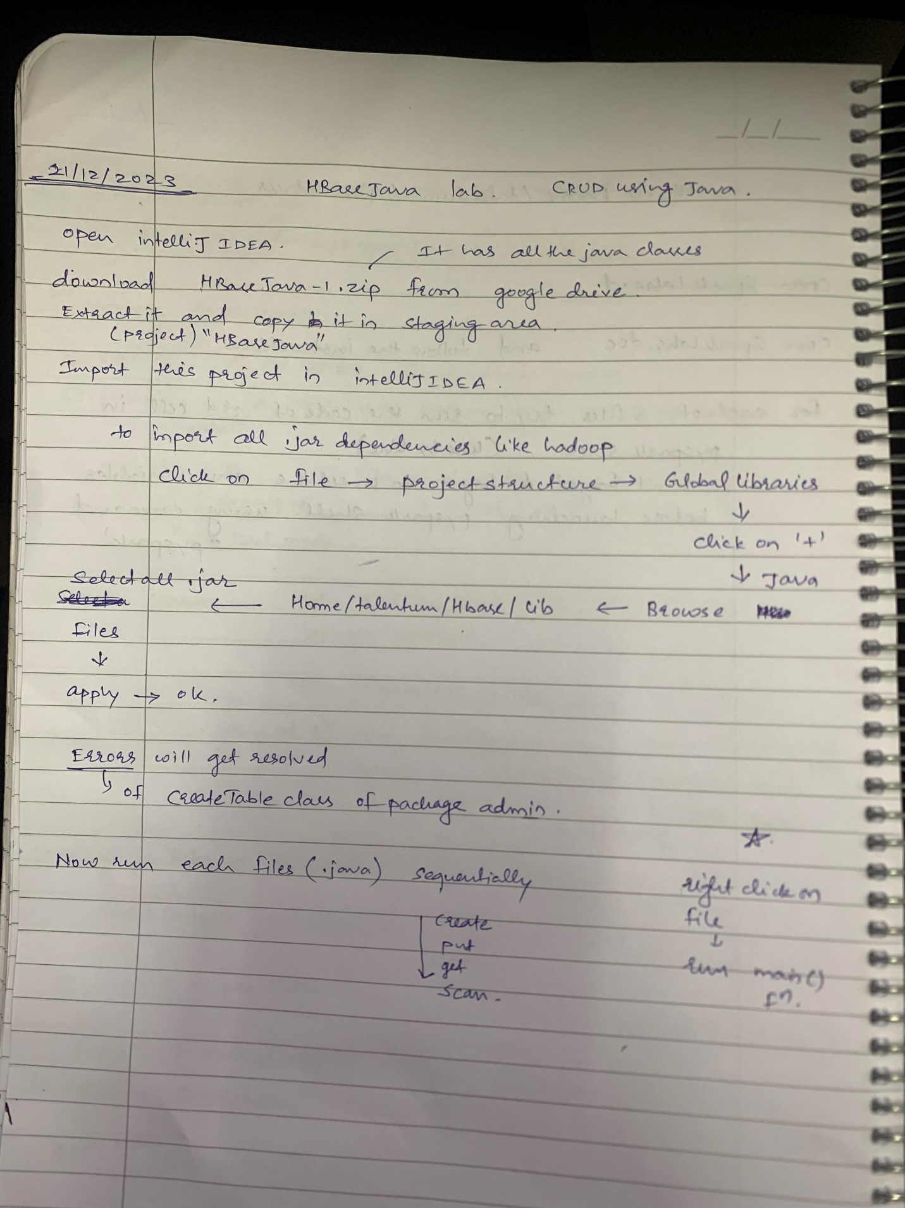

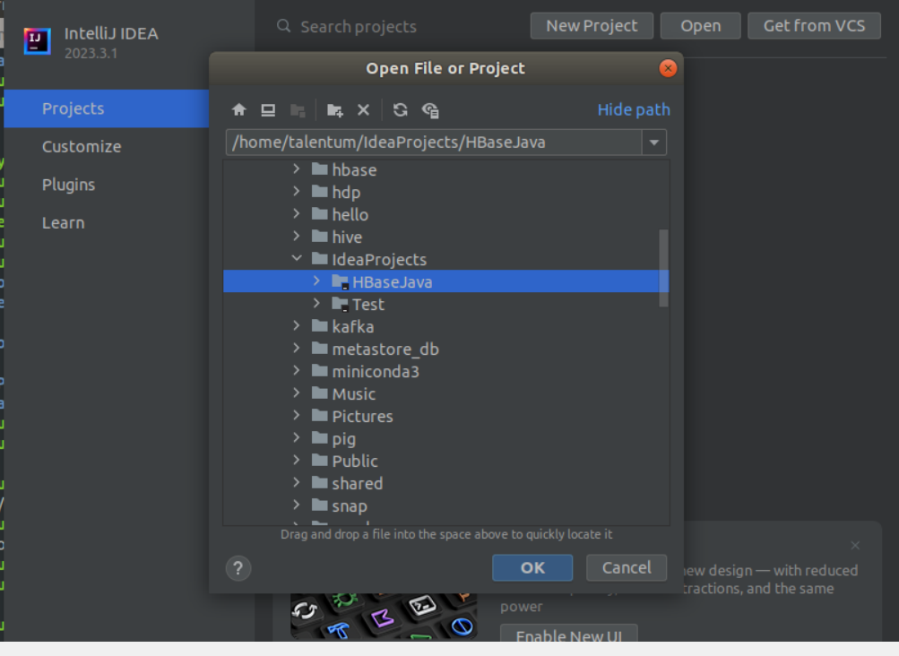

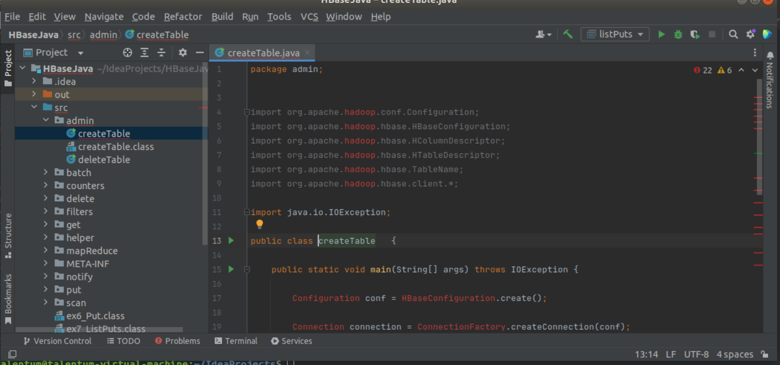

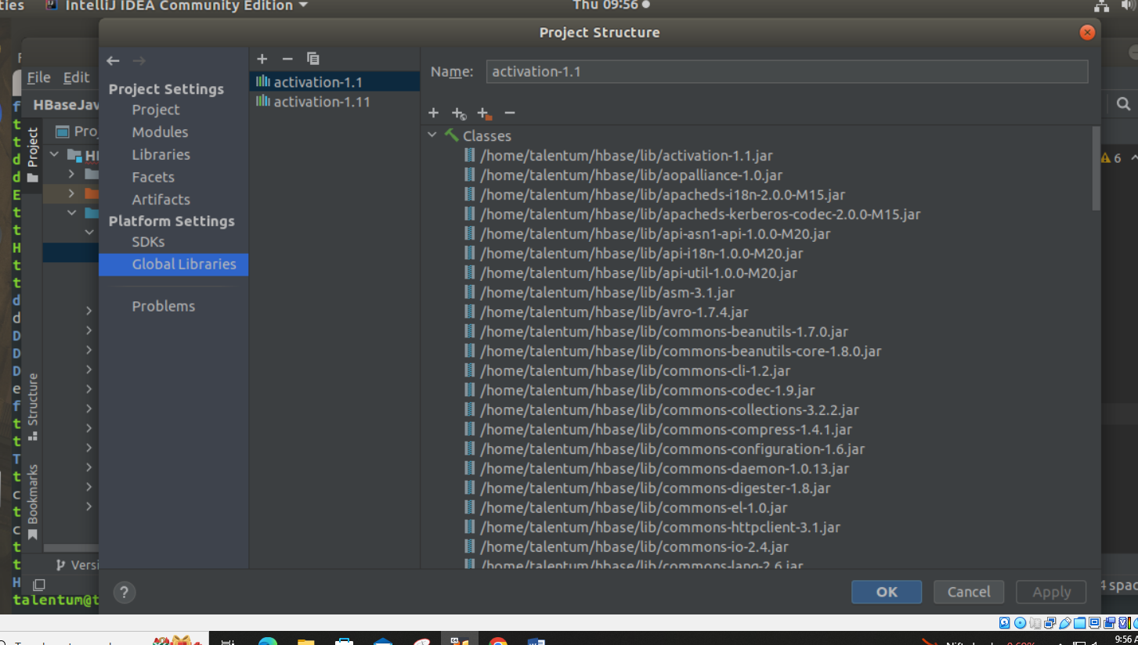

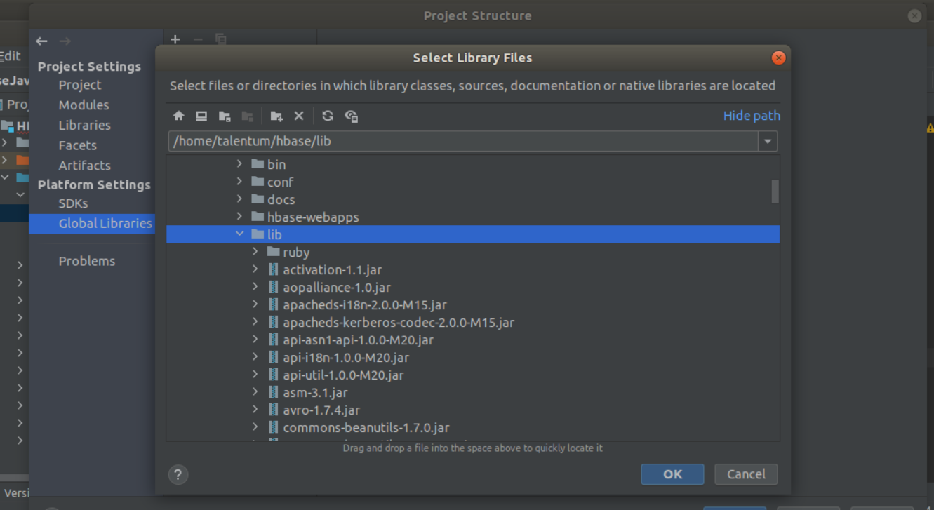

Run Create table file

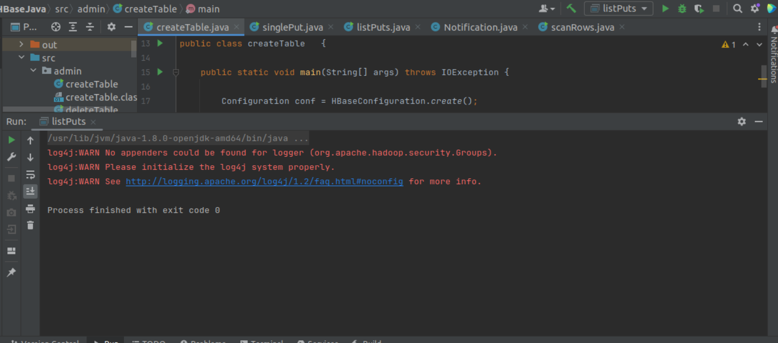

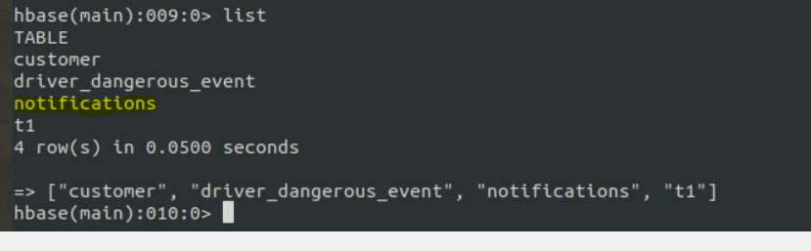

Run Single Put

And listput

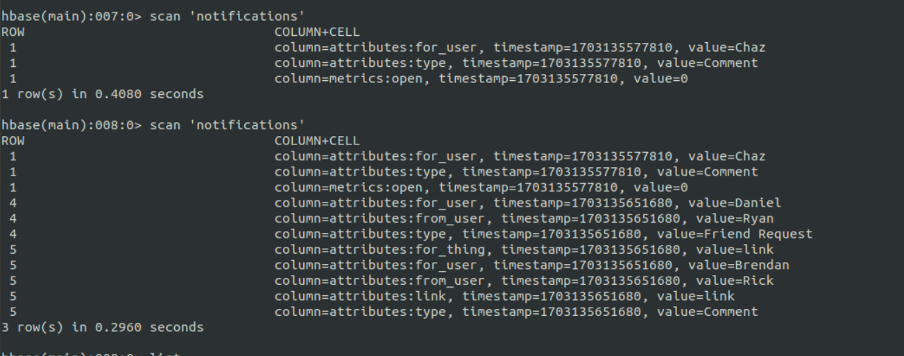

Change the row id in the code- given-2 change to 1

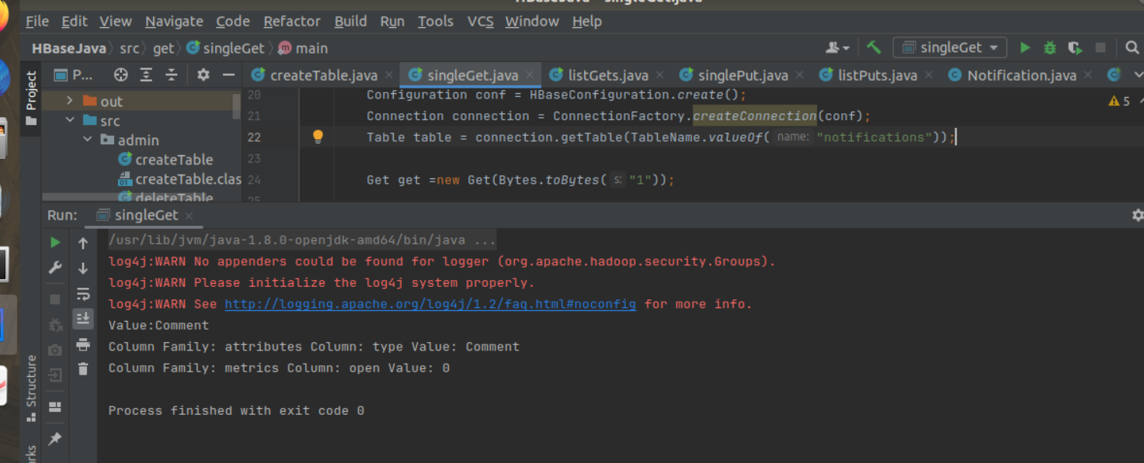

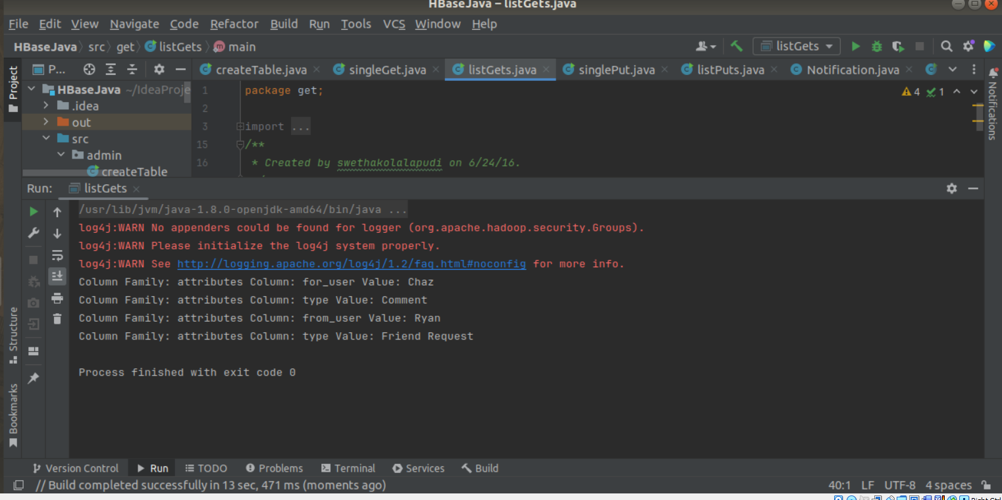

Run remaining files

------------------------------------------------------------------------------------------------------------------------------------------

In file Ex2_Interactive Use of Pyspark

Run paragraphs

And then

Help(sc.parallelize) to view documentation

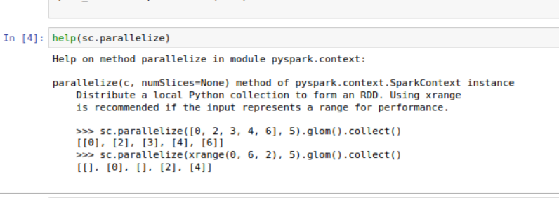

Another way

See doucumentation

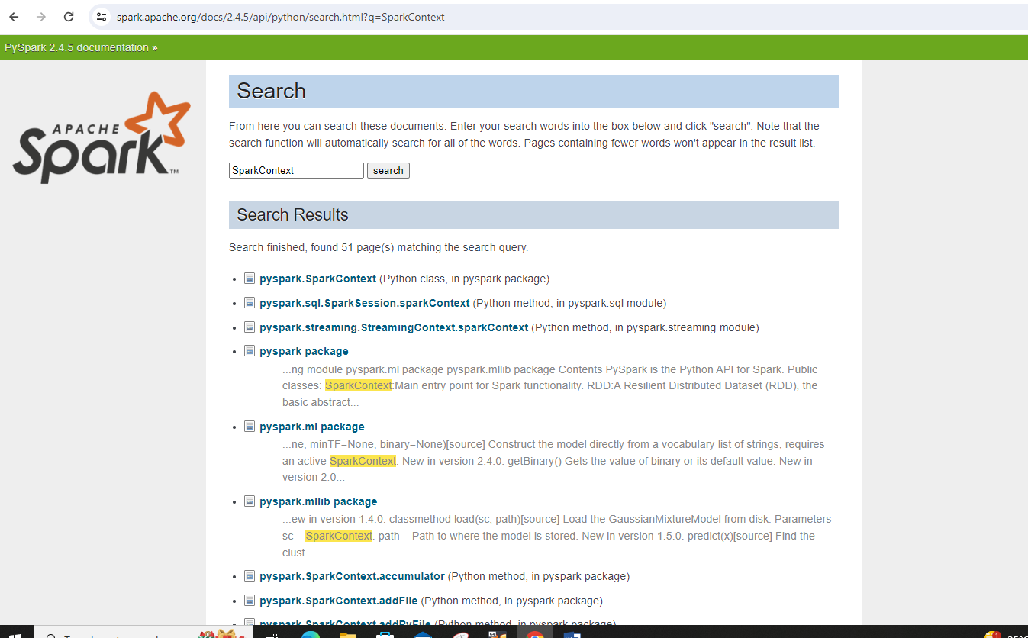

In Ex3_LoadingdatainPySparkshell

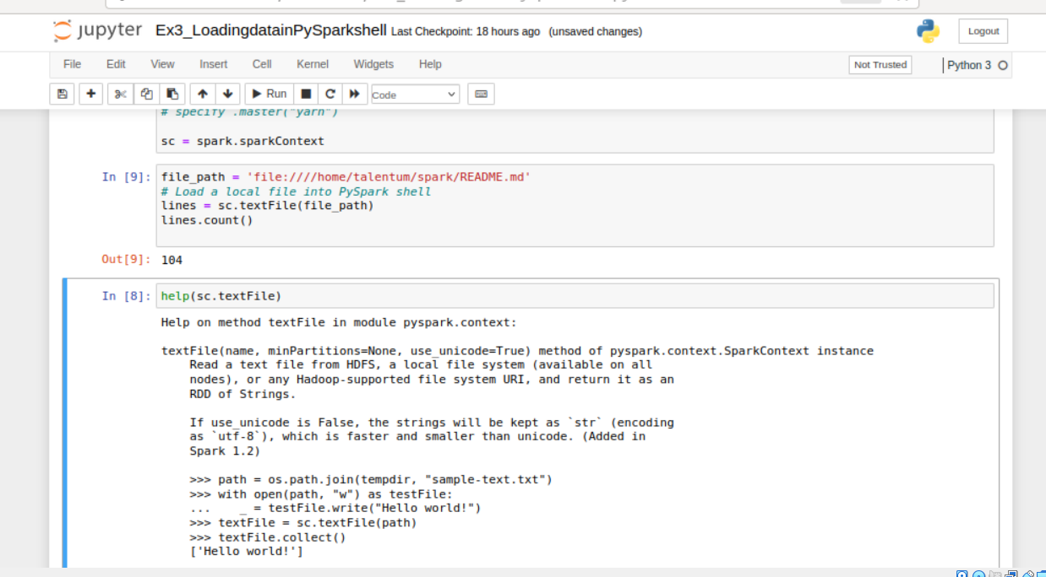

See documentation

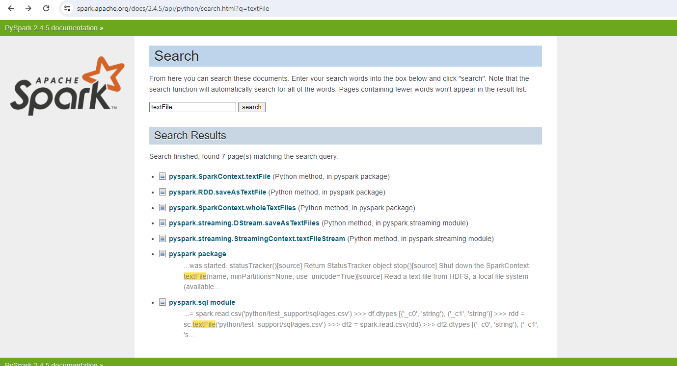

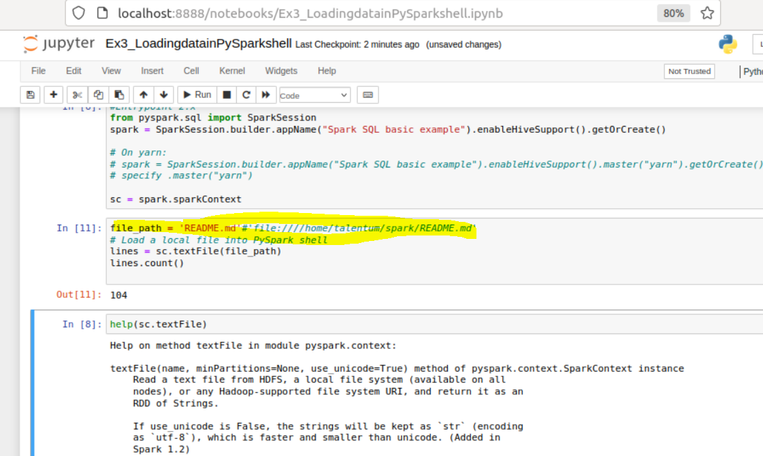

Will Give error

Save this file in Hadoop



Make changes and run again

It will run now

3] BigData Fundamentals With Pyspark (M1 Introduction to Big Data analysis with Spark

Review of functional programming in Python (M1->SM3)

1) Download RAR on STAGING_AREA

2) Extract the RAR

3) Put the .ipynb files in UBUNTU_HOME/test-jupyter/P2/M1/SM3

Import in Jupyter Notebook and implement

* Code/Dataset

data/3_ReviewOfFunctionalProgramming.rar

Time = 15 Mins.



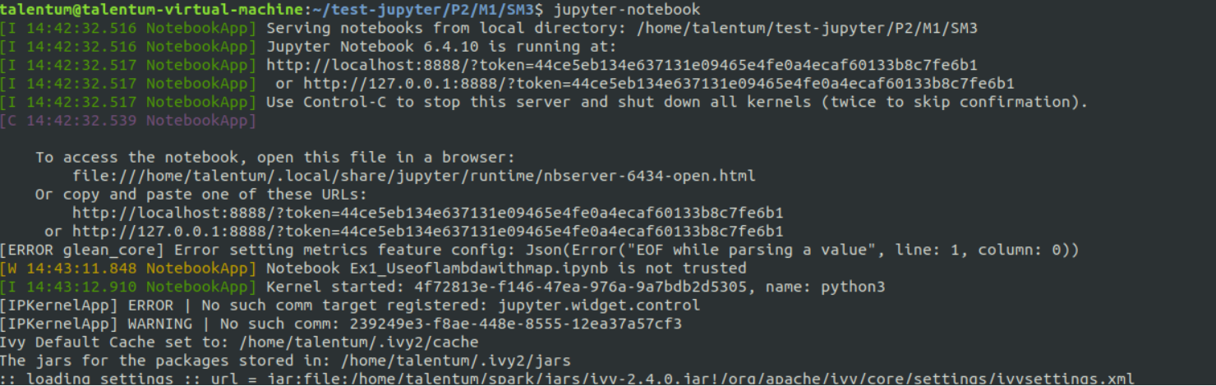

Ex1_U

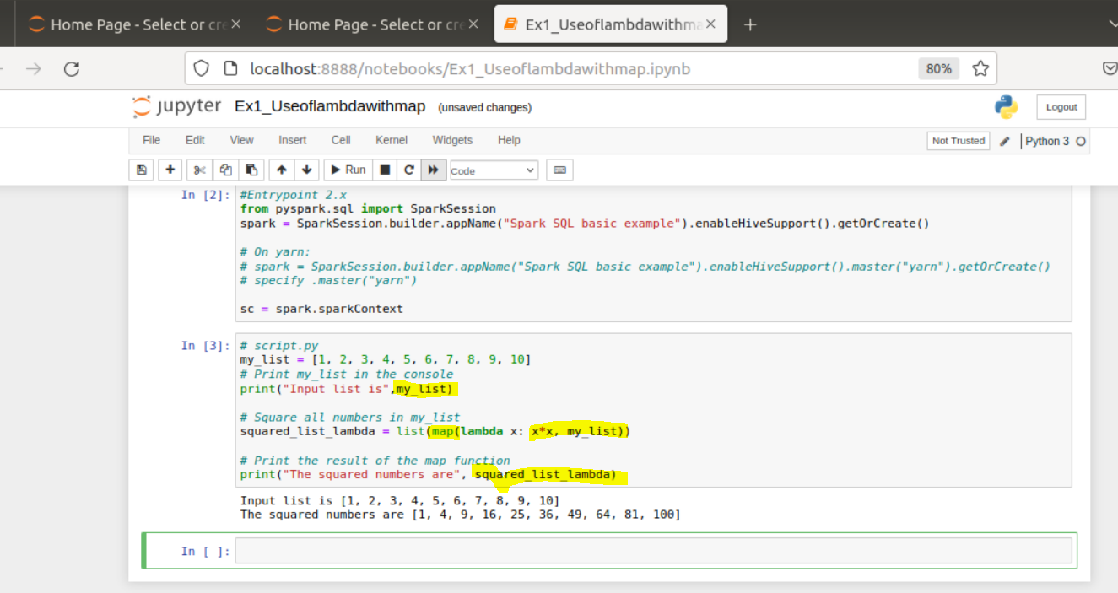

Ex2_Use of Lambda with filter

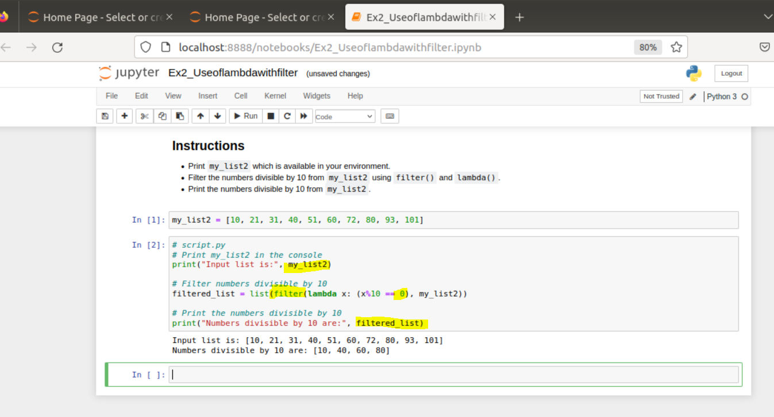

4] Big Data Fundamentals with PySpark (M2 Programming in PySpark RDD’s

Abstracting Data with RDDs (M2->SM1)

1) Download RAR on STAGING_AREA

2) Extract the RAR

3) Put the *.ipynb files in UBUNTU_HOME/test-jupyter/P2/M2/SM1

4) Import the notes in Jupyter Note book

5) Follow the instructions and give the solutions

* Code/Dataset

data/1_AbstractingDatawithRDDs.rar

Time == 20 Mins

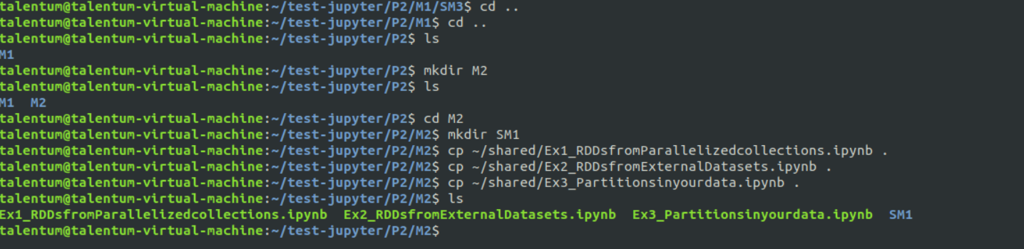

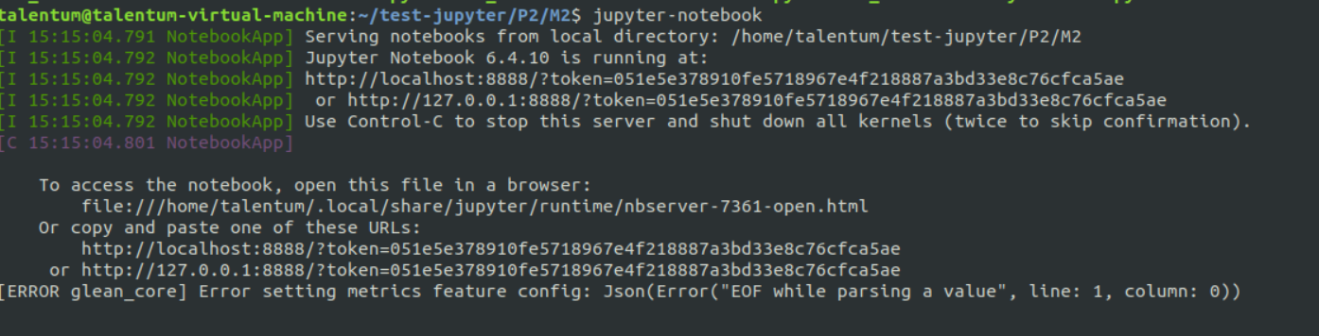

EX1

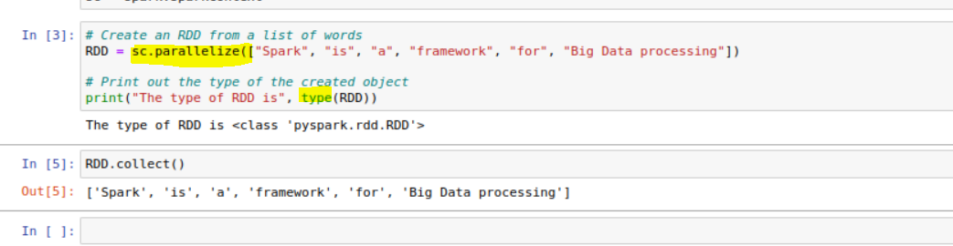

EX2

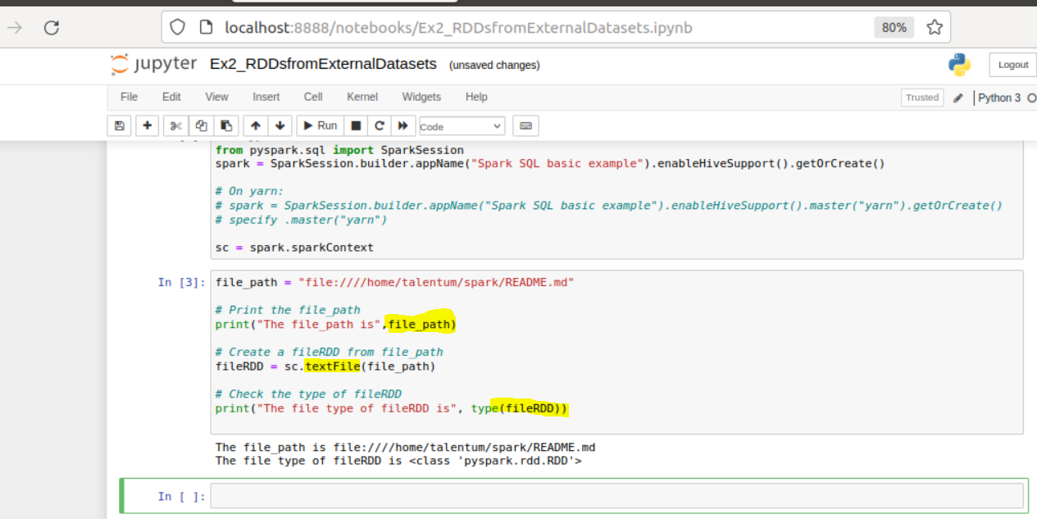

EX3

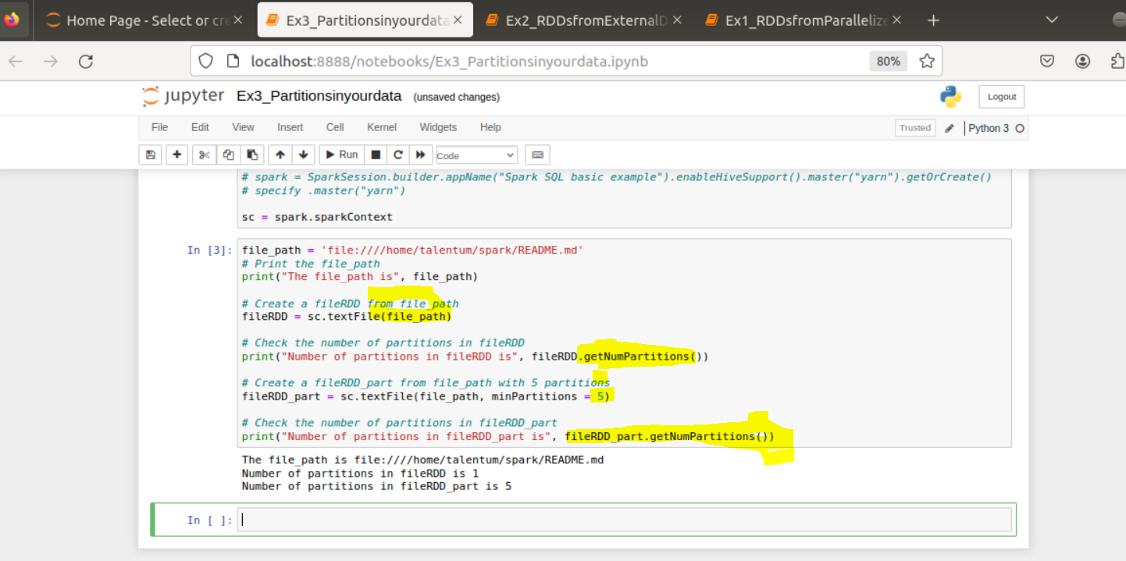

Try this

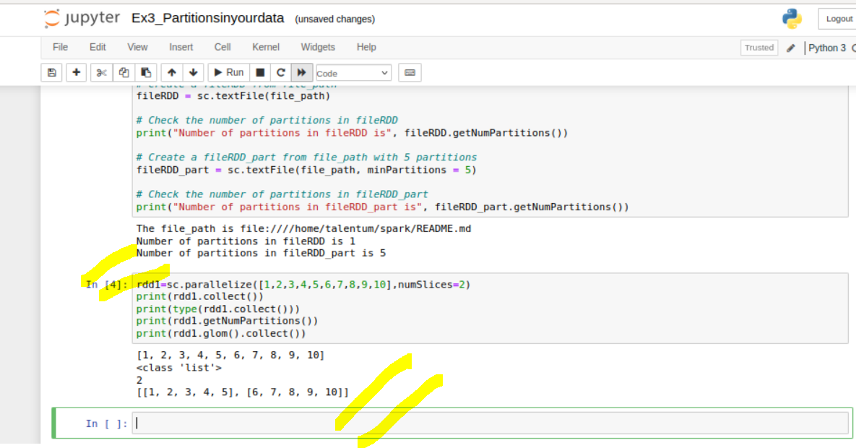

What is glom in pyspark?

glom ()[source] Return an RDD created by coalescing all elements within each partition into a list.

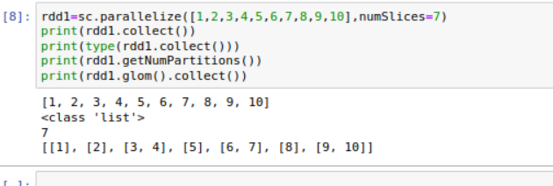

5] Big Data Fundamentals with PySpark (M2 Programming in PySpark RDD’s )

Basic RDD Transformations and Actions (M2 -> SM2)

1) Download RAR on STAGING_AREA

2) Extract the RAR

3) Put the *.ipynb files in UBUNTU_HOME/test-jupyter/P2/M2/sm2

4) Import the notes in Jupyter Notebook

5) Follow the instructions and give the solutions

* Code/Dataset

data/2_BasicRDDTransformationsandActions.rar

**TimeLine** = 20 Minutes

